Capstone Project - The Battle of Neighborhoods: Boston’s Future

**Submitted by:** Darko Knezevic

**Date:** March 2020

Table of Contents

Introduction 2

Problem Statement 3

Objective 3

Data 3

Methodology 4

Data Cleansing 4

Exploratory of Data 4

Statistical Summary of Crime in 2018 4

Districts with the Highest Number of Crime in 2018 5

Distribution of Crime Throughout the Week in 2018 6

Types of Crime in 2018 6

Location of Shootings within the last Few Years 7

Results 9

Common Venues in the Safest Area 9

Common Venues in the Safest Area 10

Clustering from 2015 to 2018 11

Clustering Crime into Two Clusters 11

Clustering Crime into Four Clusters 12

Clustering Crime into Five Clusters 13

Discussion 13

Conclusion 14

Appendix 15

Current Boston Police Department Legend 15

Current Boston Police Districts Map 16

The Percentage of Crime in Previous Years 17

# Introduction

Boston is the capital of the U.S. state of Massachusetts. It is a city with a growing economy and a great place to acquire an education. Some of the most prestigious schools within the U.S.A are in Boston. A lot of large companies are seeking to place their firms in Boston. It is a global city that is placed among the top 30 most economically powerful cities in the world. Boston's colleges and universities exert a significant impact on the regional economy. Boston attracts hundreds of thousands of students from around the world, who contribute billions of dollars annually to the city's economy. The city is considered highly innovative for a variety of reasons, including the presence of academia, access to venture capital, and the presence of many high-tech companies. Tourism also composes a large part of Boston's economy.

# Problem Statement

The amount of crime needs to be understood for Boston to continue to thrive as a major hub for innovation, tourism, academia, and employment. If the Boston Police Department knew more about which areas to concentrate on, then Boston’s citizens, tourists, and students would feel much safer. Certain areas within the city could be targeted for more protection by the Boston Police Department based on data.

# Objective

This project aims to select the safest and least safest areas in Boston based on the total crimes, explore the venues in these areas and finally cluster the areas using k-mean clustering. This report will be targeted to the Boston Police Department who are looking to analyze crime incidents, as the city continues to be a leader in so many fields. The crime statistics will provide an insight for the Boston Police Department towards their approach in dealing with different areas of city. The most common venues in the safest areas will be explored.

# Data

Based on definition of our problem, factors that will influence our decision are:

* The total number of crimes committed in each major area during the most recent year available. For example, acquiring data from the most recent year available will be done to do analysis.
* The most common venues in the area that is the safest.
* The total amount of crime that have been committed from the year 2015 to 2018 will be analyzed for clustering purposes. More data will allow for more data analysis to be done.

Following data sources will be needed to extract/ generate the required information:

* [Preprocessing a real-world data set from Kaggle showing the Boston Crimes from the](https://render.githubusercontent.com/view/ipynb?commit=eaf51605d1d8fc685c94785a37639f71d62b33d1&enc_url=&nwo=Shekhar-rv%2FCoursera_Capstone&path=Capstone+Project+-+The+Battle+of+Neighborhoods+-+Final%2FCapstone+Project+-+The+Battle+of+the+Neighborhoods+-+London+Neighborhood+Clustering.ipynb&repository_id=181697421&repository_type=Repository#part1) last few years. Kaggle, a subsidiary of Google LLC, is an online community of data scientists and machine learning practitioners. Kaggle allows users to find and publish data sets, explore and build models in a web-based data-science environment, work with other data scientists and machine learning engineers, and enter competitions to solve data science challenges.

The Boston crime file provides information about the following:

* INCIDENT_NUMBER
* OFFENSE_CODE
* OFFENSE_CODE_GROUP
* OFFENSE_DESCRIPTION
* DISTRICT
* REPORTING_AREA
* SHOOTING
* OCCURRED_ON_DATE
* YEAR
* MONTH
* DAY_OF_WEEK
* HOUR
* UCR_PART
* STREET
* LATITUDE
* LONGITUDE
* LOCATION

Data Set URL: <https://www.kaggle.com/AnalyzeBoston/crimes-in-boston>

# Methodology

## Data Cleansing

* From the Boston crime data, the data from the year 2018 was initially analyzed to understand key drivers in the most recent year. However, as the study progressed in order to effectively do k-means clustering more data from previous years was required.
* All the data values that didn’t have a district associated with an incident were removed from the dataset for certain types of analysis.
* Missing data were coming from reporting area, latitude and longitude.

# Exploratory of Data

The data was graphical represented to provide the best way to present meaningful details to the audience.

## Statistical Summary of Crime in 2018

Approximately 65,141 crimes were identified in the City of Boston that have been assigned to a police district in 2018.

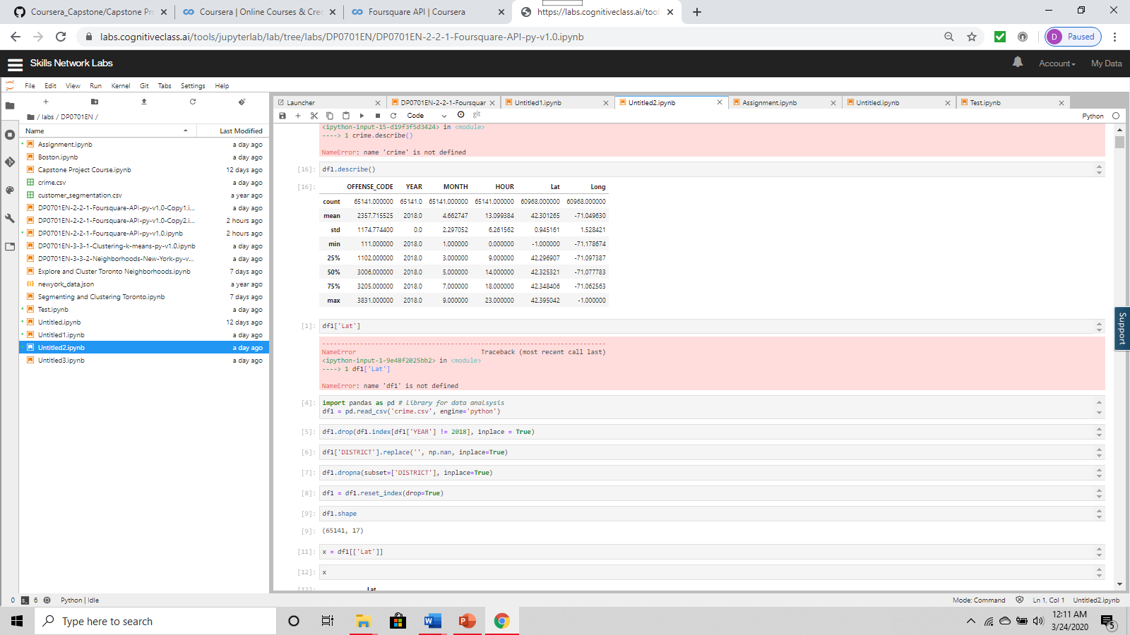

## Districts with the Highest Number of Crime in 2018

The top five districts were the most crime occurred in 2018 was at the following areas: B2, D4, C11, B3, and A1. Most of the crime that is occurring is located in the middle of the Current Boston Police Districts Map. Therefore, it might be a good idea to place more police officers in those police districts where more crime occurs.

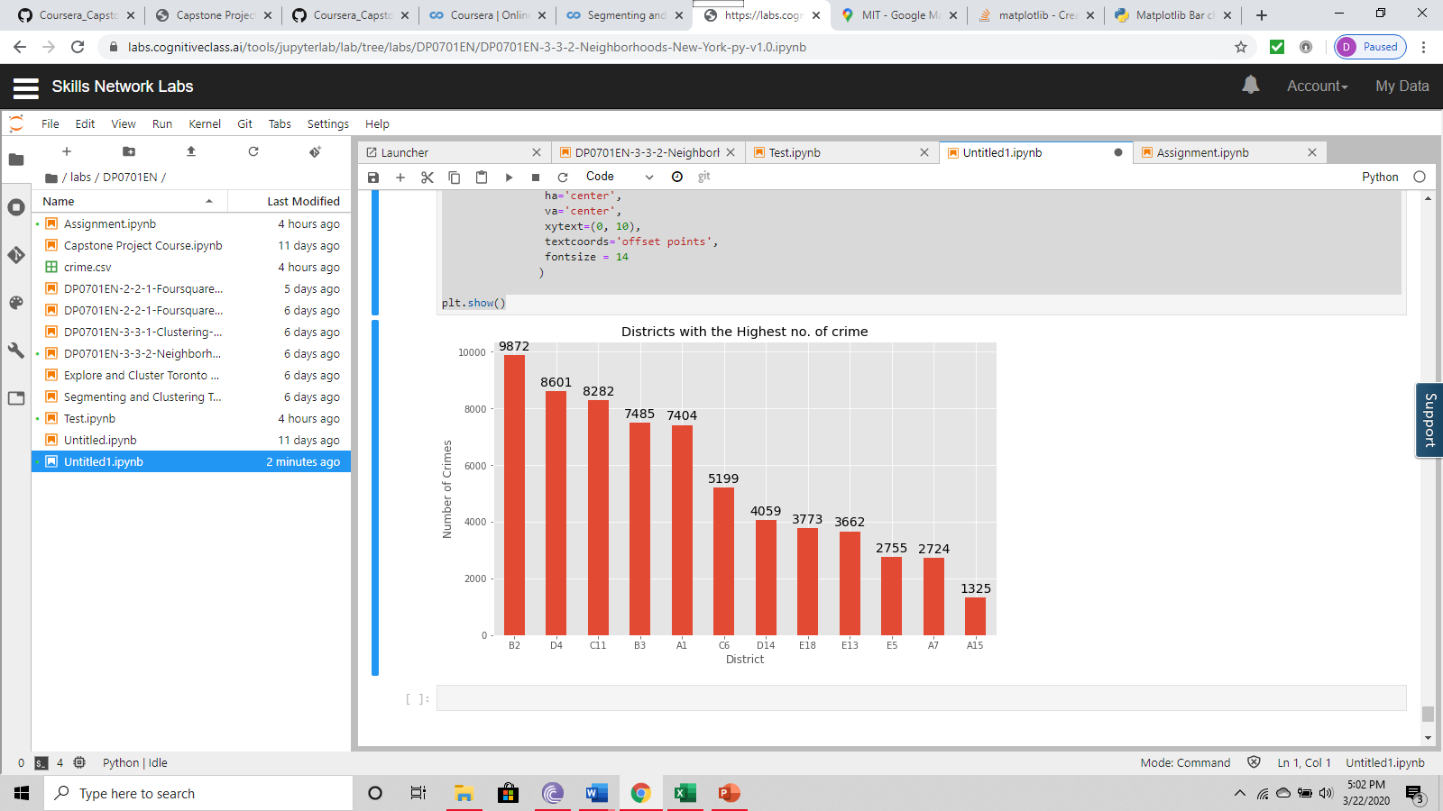

## Distribution of Crime Throughout the Week in 2018

More crime occurs as the week goes on from Monday to Friday with a reduction in the amount of crime during the week. However, there are no spikes in the amount of crime on certain days. It seems to be consistent from Monday to Friday. This data was extracted from the year 2018.

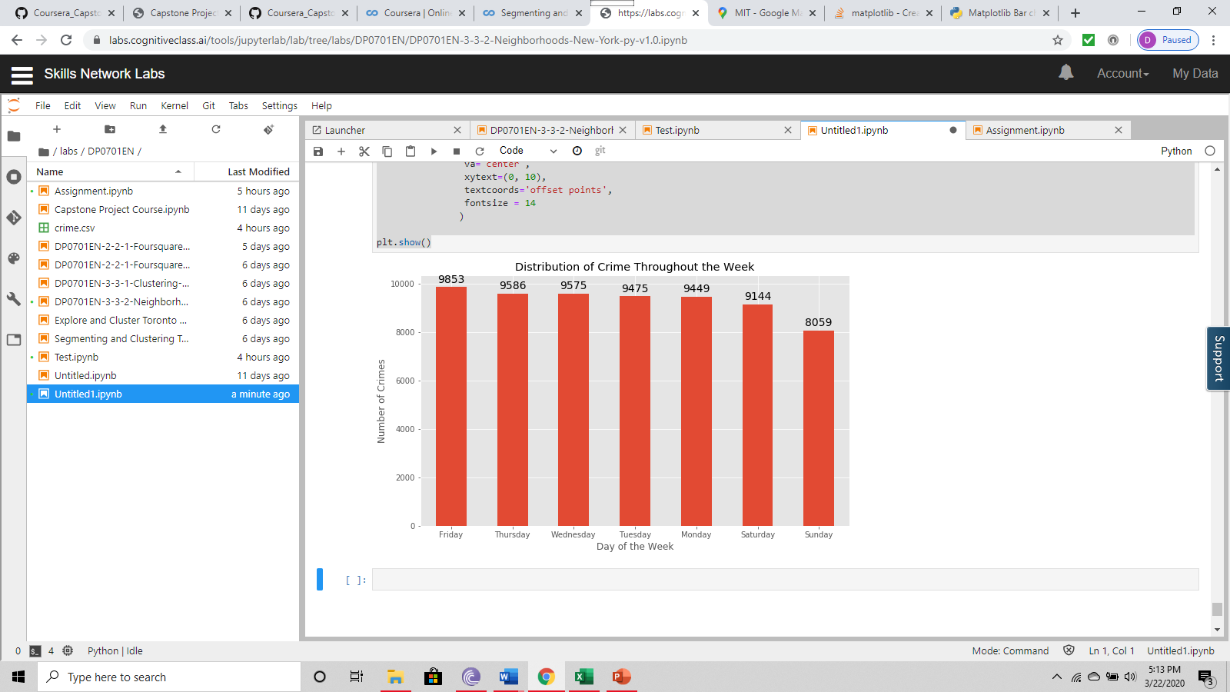

## Types of Crime in 2018

There is a large spike in the amount of crimes have been related to motor vehicle accident response, medical assistance, and latency. The graph below represents a view of the top ten types of crime that have occurred in Boston in 2018.

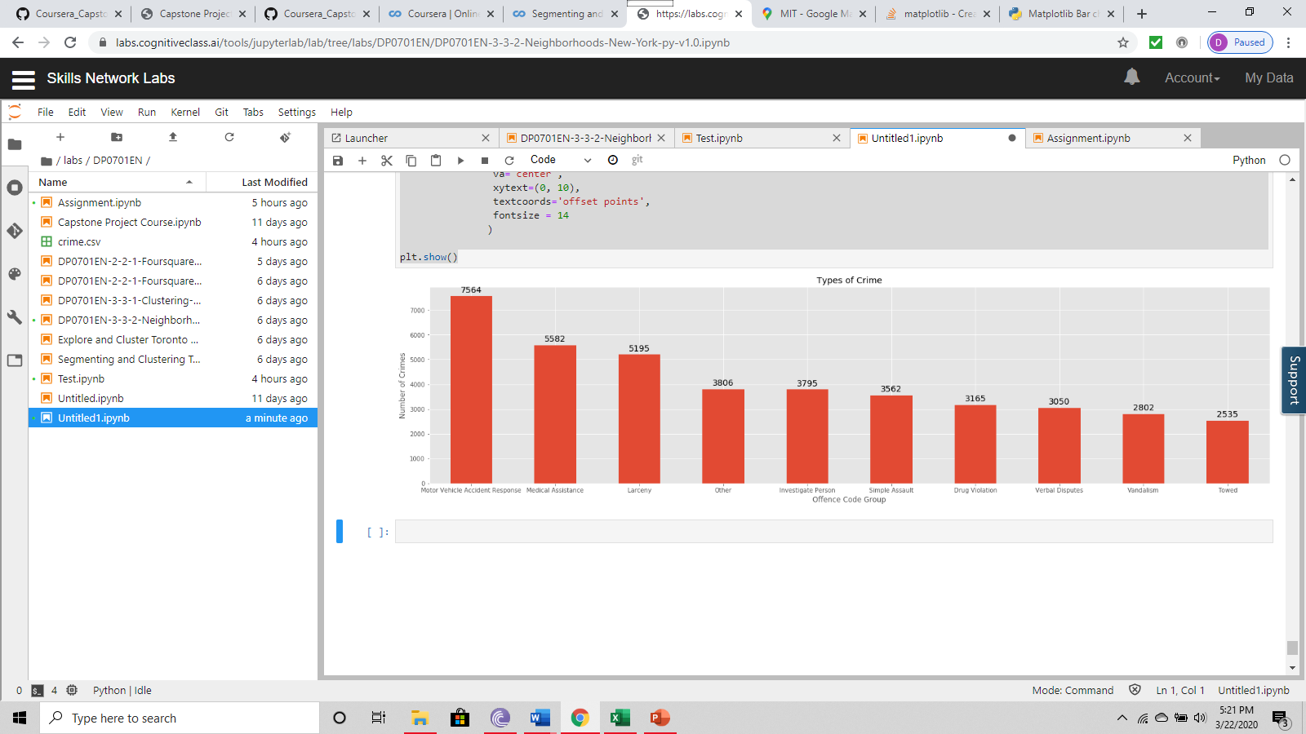

## Location of Shootings within the last Few Years

Most of the shooting in Boston within the last few years have been located in the centre of the Boston Police Districts.

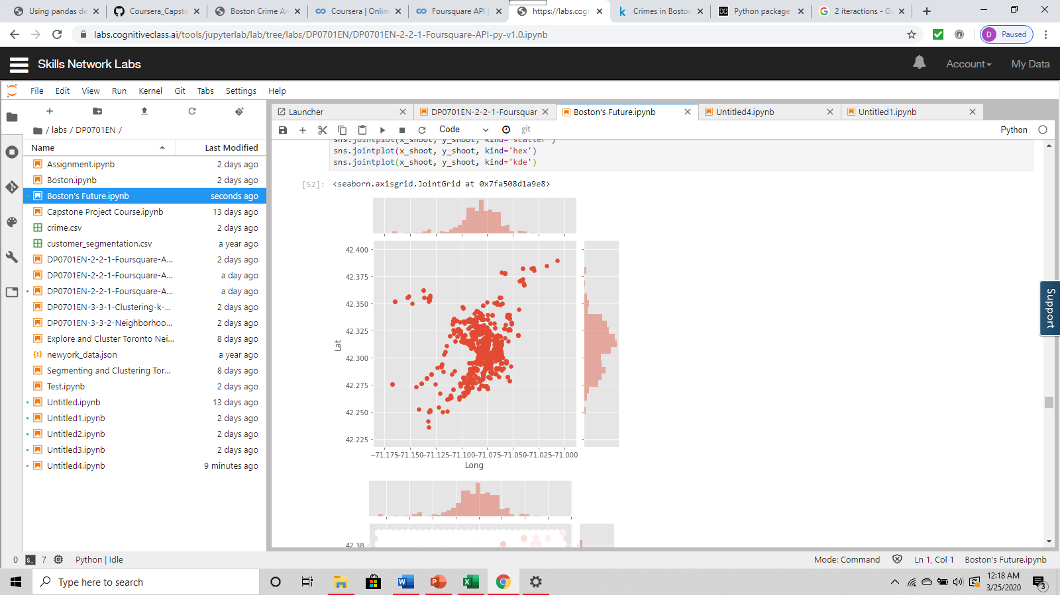

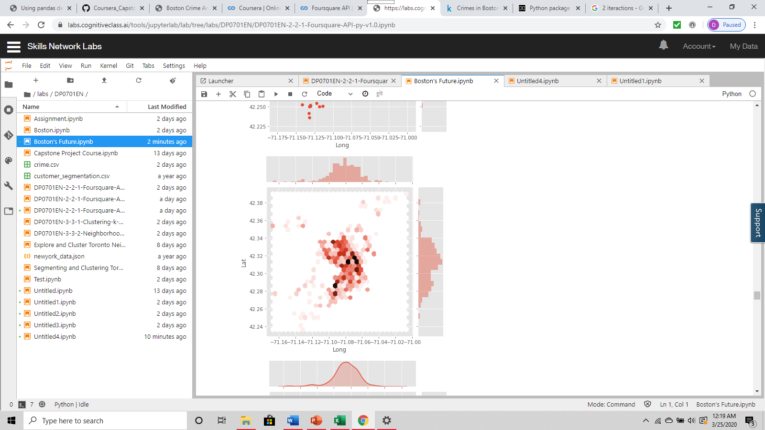

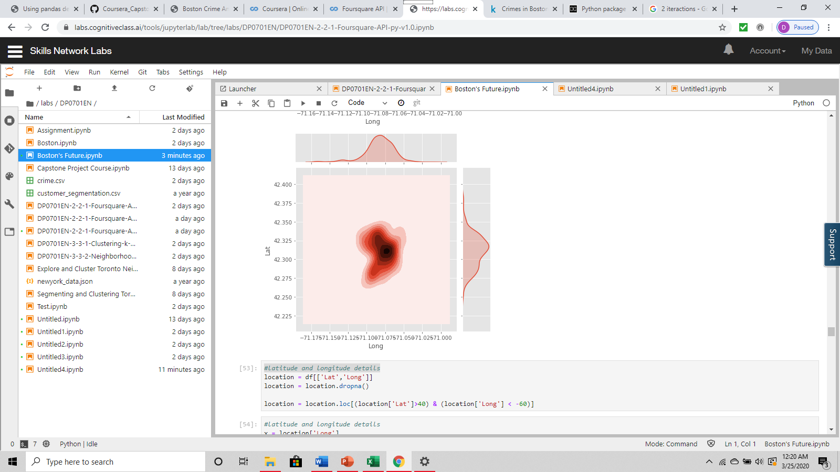

# Results

## Common Venues in the Safest Area

Foursquare is a social location service that allows users to explore the world around them. A Python package to get venues from Foursquare API into Pandas data frame was used for this project.

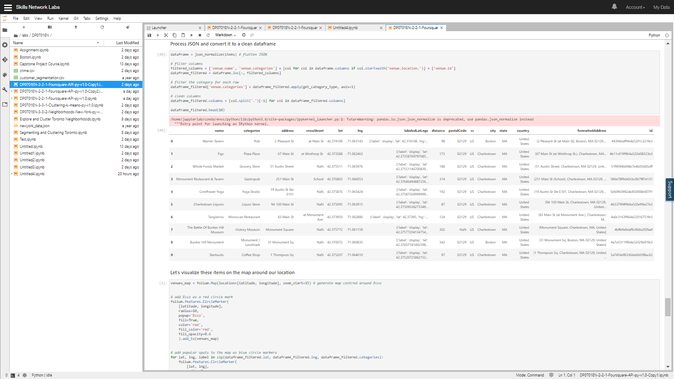

## Common Venues in the Safest Area

The safest police district has been identified as A15. The locations of the venues seen above can visually be seen below. The red dot represents a crime that has occurred in the district A15. The blue dots represent the common venues in that area.

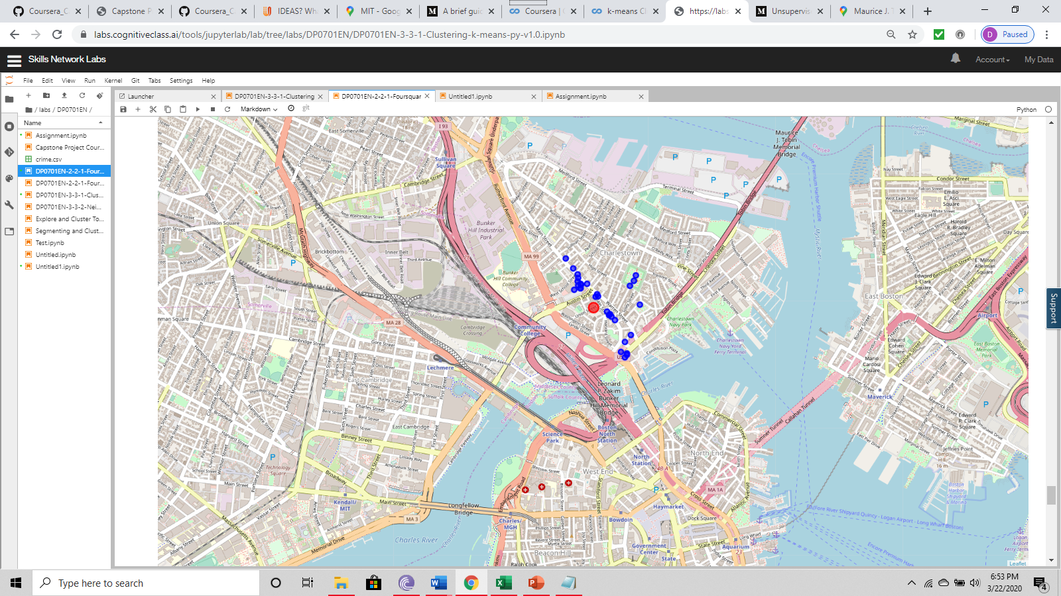

## Clustering from 2015 to 2018

K-means clustering is one of the simplest and popular unsupervised machine learning algorithms. Typically, unsupervised algorithms make inferences from datasets using only input vectors without referring to known, or labelled, outcomes.

To process the learning data, the K-means algorithm in data mining starts with a first group of randomly selected centroids, which are used as the beginning points for every cluster, and then performs iterative (repetitive) calculations to optimize the positions of the centroids

It halts creating and optimizing clusters when either:

* The centroids have stabilized and there is no change in their values because the clustering has been successful.
* The defined number of iterations has been achieved.

### Clustering Crime into Two Clusters

The crime from years 2015 to 2018 was clustered into two iterations.

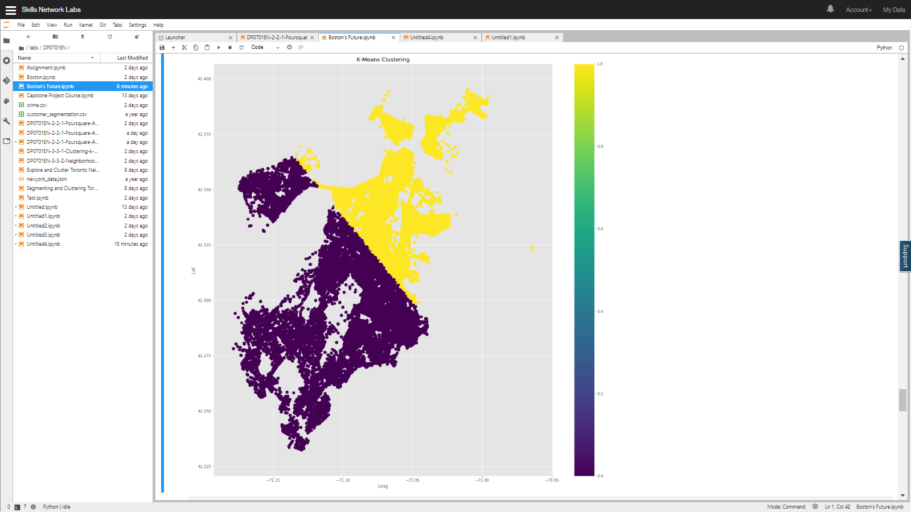

### Clustering Crime into Four Clusters

The crime from years 2015 to 2018 was clustered into four iterations.

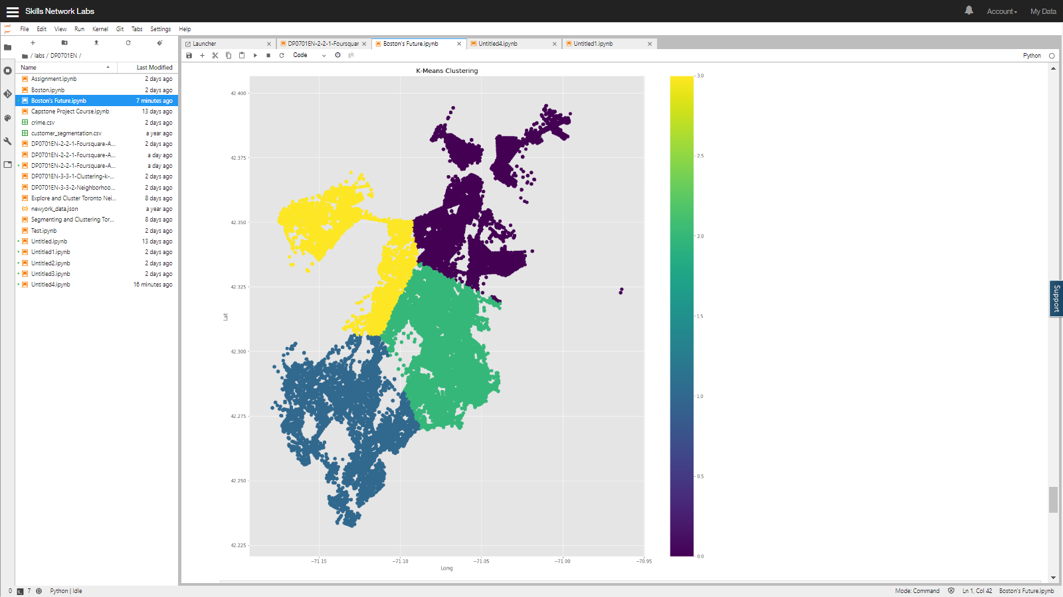

### Clustering Crime into Five Clusters

The crime from years 2015 to 2018 was clustered into five iterations.

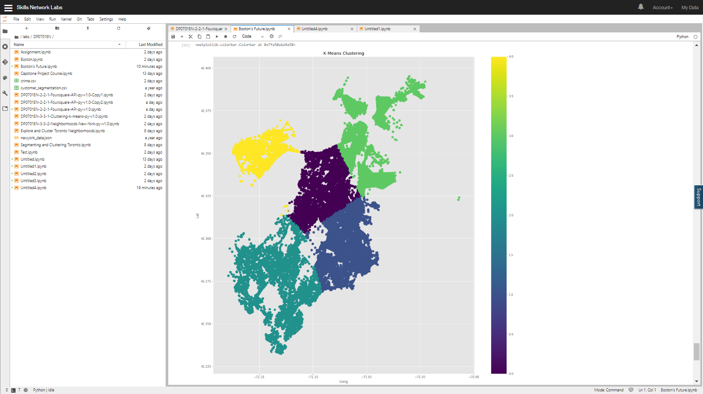

# Discussion

The Boston Police needs to place more emphasize on the areas that have a higher crime rate than in others in order to reduce the amount of crime in Boston. This will allow the city to continue to thrive and grow towards new heights. Most of the crime is occurring the centre of the Boston Police District Map. Crime seems to be on the rise when examining previous years. It would be a great idea to analyze more information about the shootings that are occurring within the city. The income level of certain parts of the city could be analyzed as well. This would provide the ability to see whether there is a correlation between income levels and shooting. In the past, Boston's low crime rate since the 1990s has been credited to the Boston Police Department's collaboration with neighborhood groups to prevent youths from joining gangs, as well as involvement from the United States Attorney and District Attorney's offices. Maybe such measures need to be implemented again to ensure that the crime levels in Boston can be reduced.

# Conclusion

After performing in-depth analysis on the Boston Crime data set, we can clearly see the trends and relations between the types of crimes and location. Some of the notable takeaways from the analysis are mentioned below:

1. Most crime occurs is at B2, D4, C11, B3, and A1.
2. Certain venues were closely linked to drug problems and violent crime
3. Motor-Vehicle accident response were the highest number of reports registered with the Boston Police.
4. The k-means clustering of the crime data from previous years has indicated that the north part of the police districts have less crime.

This analysis can help Boston Police act accordingly and try to reduce the crimes frequently occurring in the city of Boston.

# Appendix

## Current Boston Police Department Legend

This report will also make reference to the Department’s various police

districts The districts include A1(Downtown, Beacon Hill, North End, and Chinatown), A7 (East

Boston),A15 (Charlestown), B2 (Roxbury and Mission Hill), B3 (Mattapan and portions of Dorchester), C6 (South Boston), C11 (Dorchester), D4 (Back Bay, South End, and Fenway), D14 (Allston and Brighton), E5 (West Roxbury and Roslindale), E13 (Jamaica Plain), and E18 (Hyde Park).

## Current Boston Police Districts Map

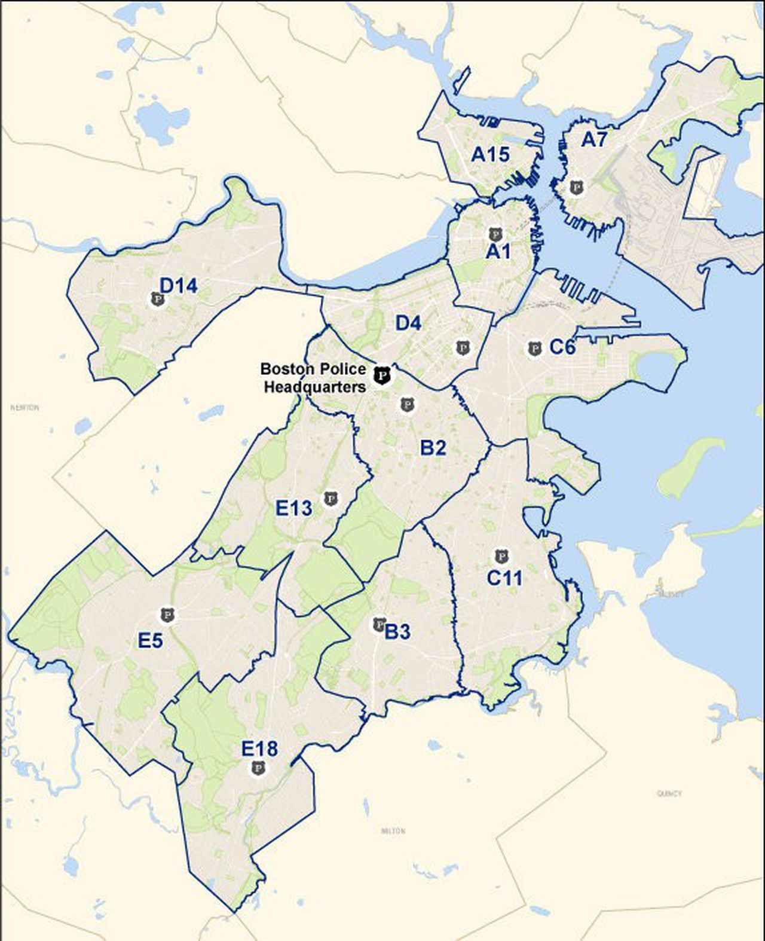

## The Percentage of Crime in Previous Years

